| IT Dept | March 23, 2020

Microsoft Teams User Guide

Contents
Key Benefits of Using Microsoft Teams 3
How to access Microsoft Teams 3
Logging into Teams for the first time 4
Scheduling on-line meetings in Teams 4
How to Join a meeting (Outlook/Teams User) 7
How to Join a meeting (External Users) 9
How to Share Screen in a meeting 11
Other useful sources of information. 11

Microsoft Teams
Microsoft Teams is an effective tool to communicate with colleagues through chats, audio/video call conferencing and sharing of files. It has all the features of Skype for Business plus many more. This guide will provide steps on how to access Teams and use some key features.

Key Benefits of Using Microsoft Teams
- MS Teams is available to all GAA Office 365 users as part of their existing licence – there is no cost to use it
- It provides the ability to have conference calls / video calls in a simple manner
- It can include people with email addresses that are not @gaa.ie ones (i.e gmail etc)
- It has excellent functionality that is integrated with all of the other main Microsoft Products

How to access Microsoft Teams
You can access Microsoft Teams in a number of different ways, the easiset of which is through your existing Office 365 account. When logged into email (http://mail.gaa.ie) click on the App Launcher in the top left hand side of your screen and select Teams, as shown below:
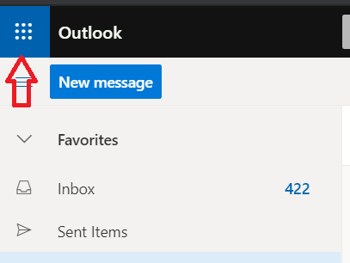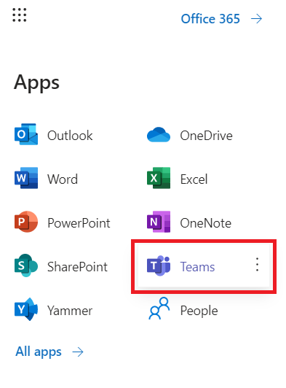
Alternatively you can sign in to Teams directly via most web browsers at the following address https://teams.microsoft.com by using your GAA email and password. You can also install the Teams App on your mobile phone or PC from this link https://teams.microsoft.com/downloads

Logging into Teams for the first time
Once you have opened Teams as described above or are in the process of joining a Teams On-Line Meeting, you will be presented with a screen similar to below. The simplest option is to select the ‘Use the Web App instead’ link – this will allow you to access teams (or your online meeting) almost immediately.
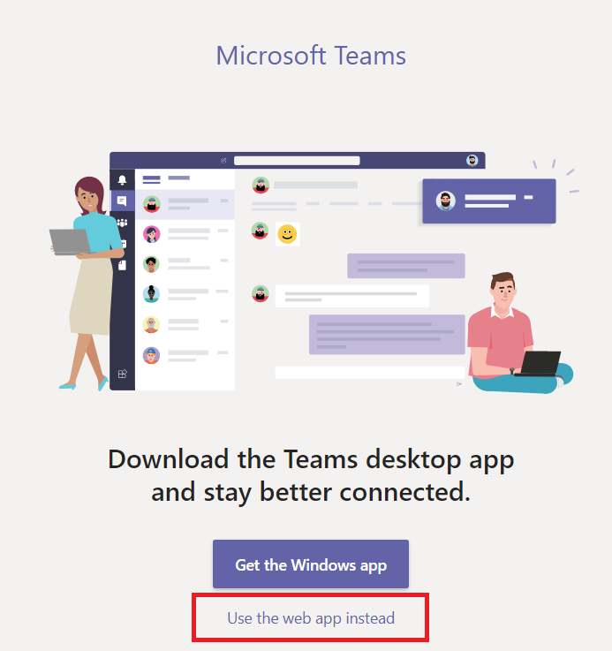
If you intend using Teams on an on-going basis, it is worth considering the ‘Windows App’ option by downloading it from the Microsoft Teams Website

Scheduling on-line meetings in Teams
Your calendar in Teams is connected to your Outlook/email calendar. In other words, when you schedule a meeting in Teams, it'll show up in Outlook, and vice versa. Every meeting scheduled in Teams is automatically made into an online meeting. To organise a meeting, please use the following steps:
- Click on the Calendar button on the left side of your Teams application
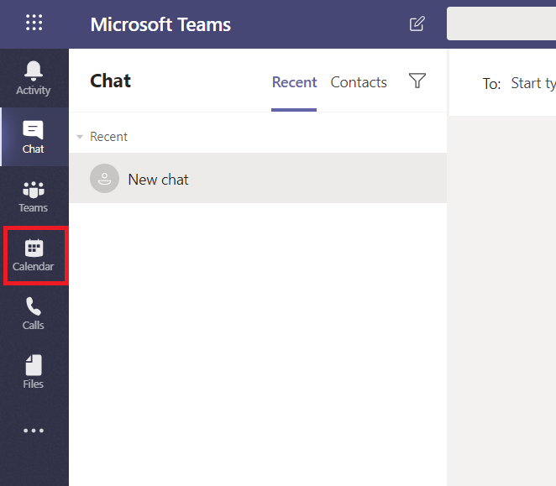
- Select New meeting in the top right corner
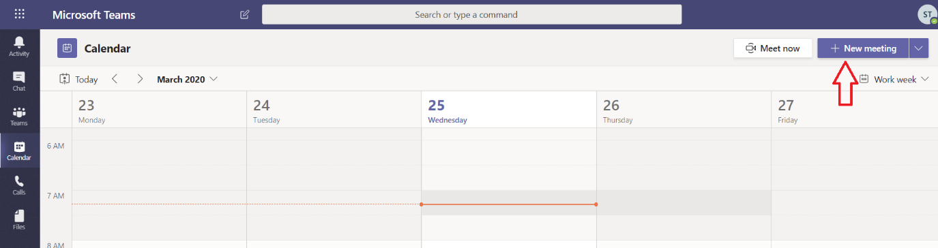
- Add a meeting title or subject (1), invite people (2), schedule the time and date (3) and add meeting details (4).
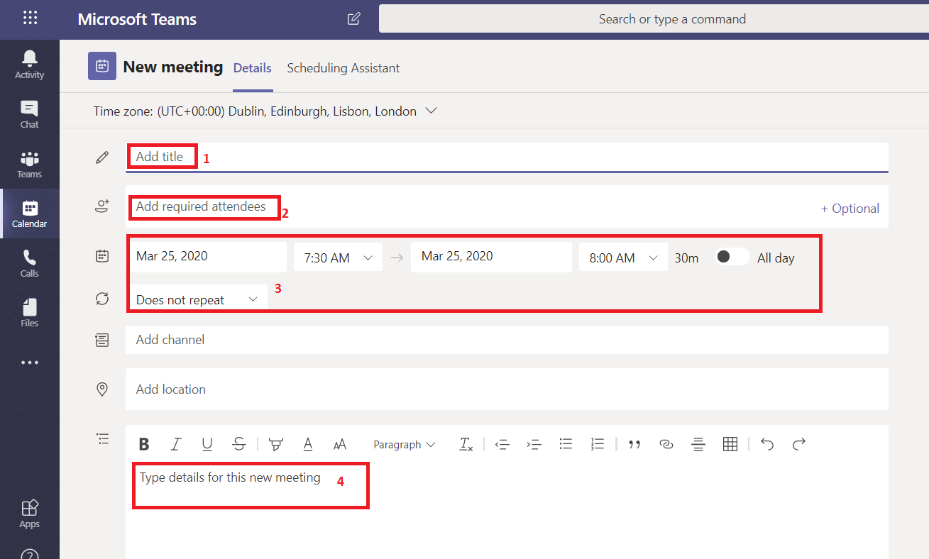
- To invite people to this meeting
  - click on the box that says Add required attendees.
  - Type the person's full email address, a grey box should appear underneath with a list of names, select the relevant person.
  - You can also invite External attendees in this manner
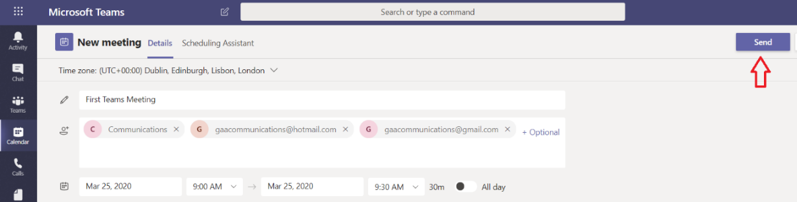
  - Once you have filled in all the relevant information, click on the Send button on the top right to send to invite.
- Once the meeting has been sent, it will appear in your calendar at the relevant time
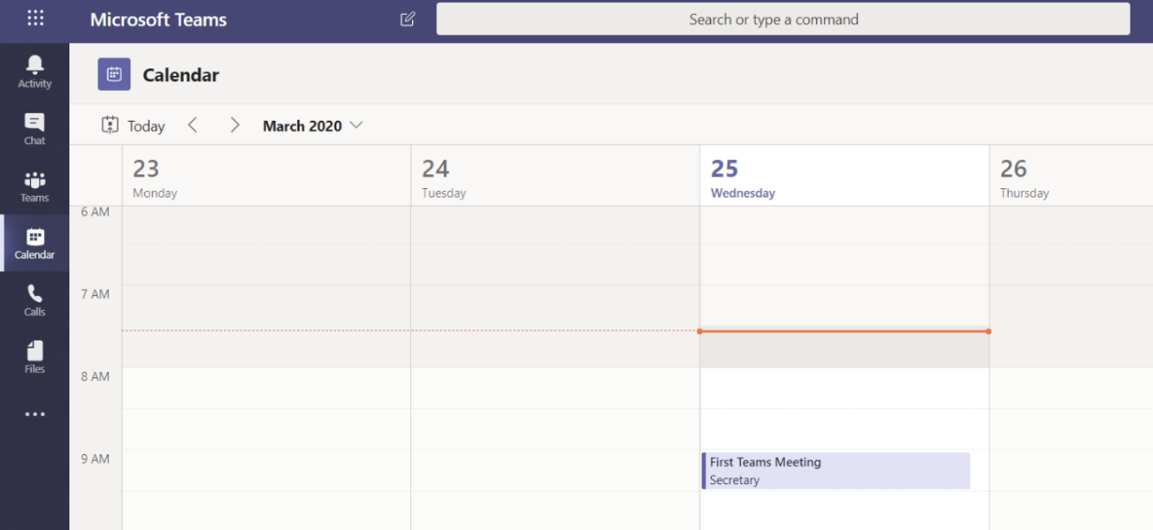

How to Join a meeting (GAA Email User)
- In your email invite, select Join Microsoft Teams Meeting.
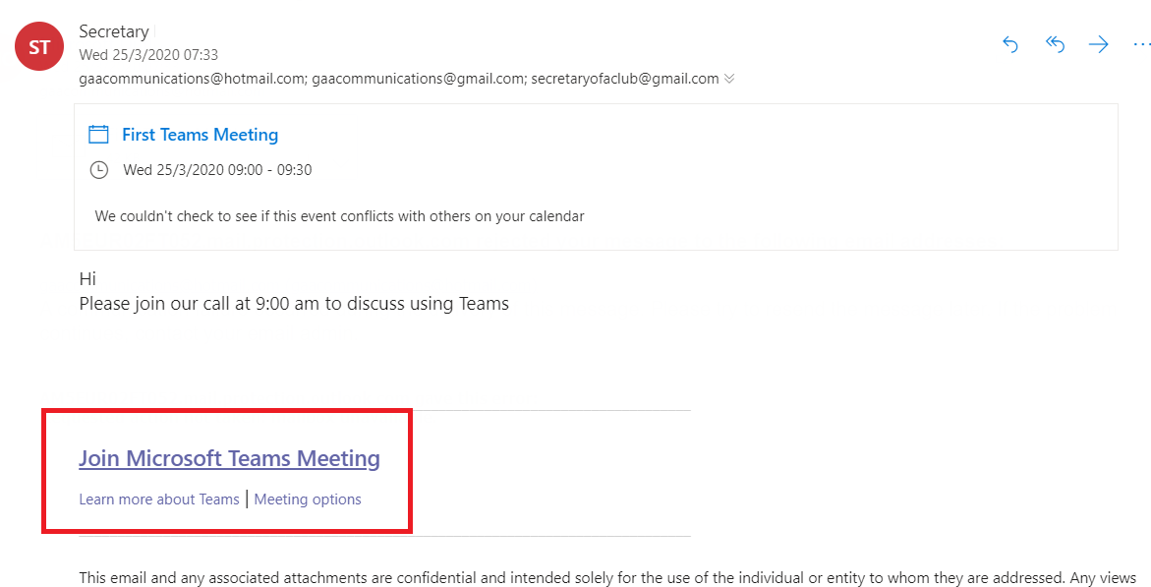
- Or in your Outlook or Teams Calendar click on the meeting and click on Join Teams Meeting.
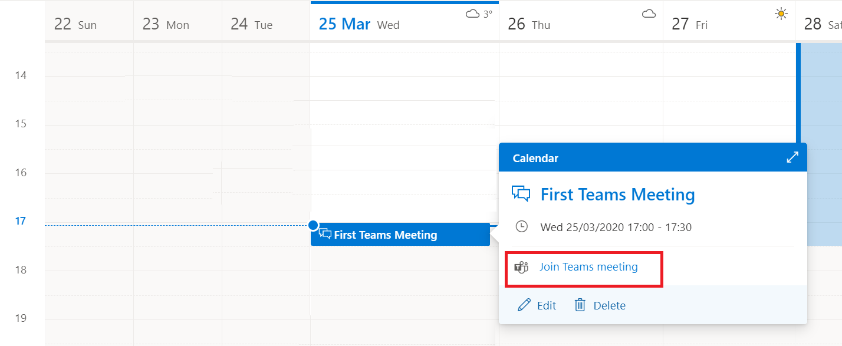
- You might be asked to give permission to use your microphone and camera, please click Allow
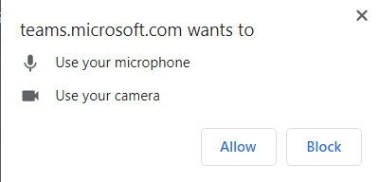

- You can mute your microphone or turn off your camera by clicking on the relevent buttons.
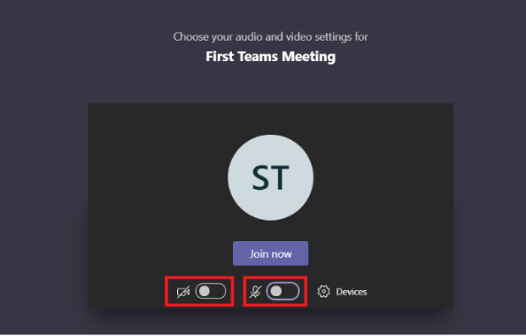
- Click Join now to join the meeting.
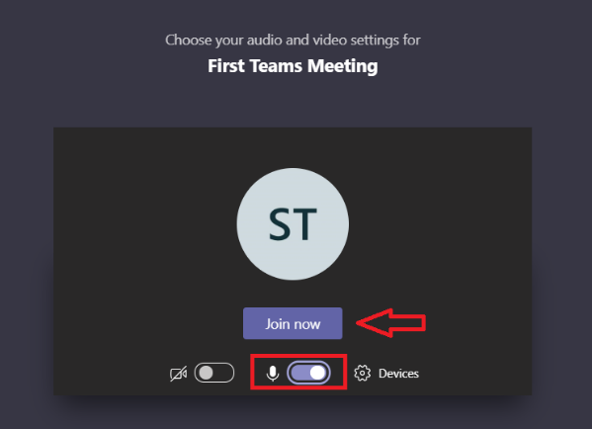
- You may have to wait for the meeting to start. You will have the option to turn on / off your Mic and Camera (1), to share your screen (2), to see who’s on the call (3) or to exit the call (4) at any time during the meeting.
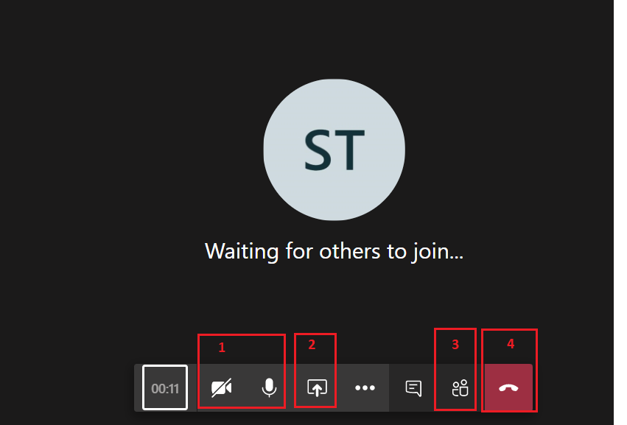

How to Join a meeting (External Users)
People who do not have @gaa.ie email addresses can still join a Teams meeting that has been scheduled by someone in the GAA. They are simply invited to join the meeting as previously described and then follow these steps
- In your email invite, select Join Microsoft Teams Meeting.
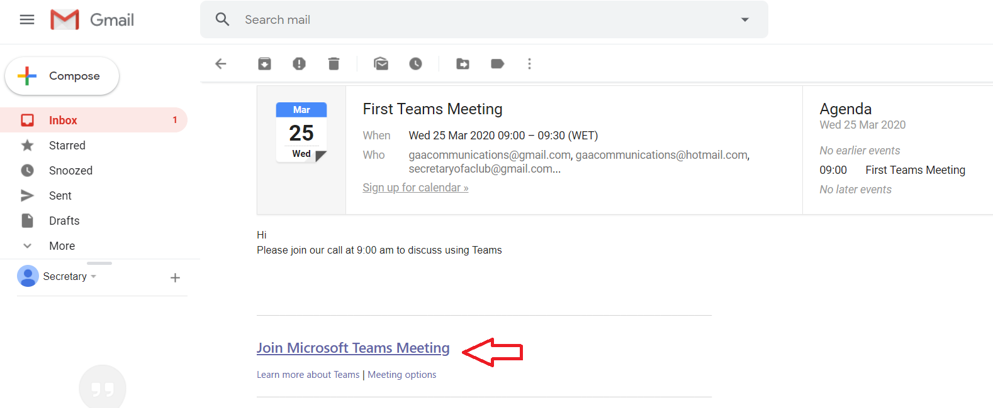
- If prompted click on Join on the web instead. If you wish you can download and install the Windows App
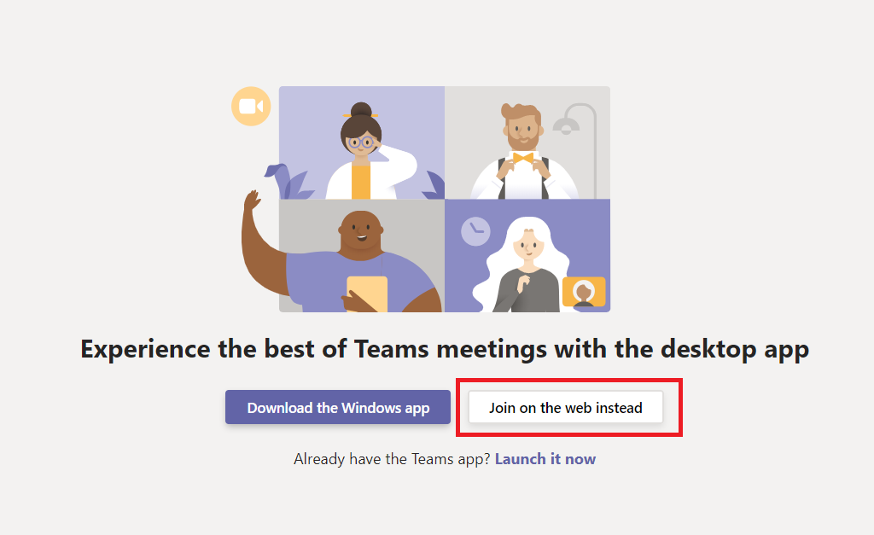

- You might be asked to give permission to use your microphone and camera, please click Allow
- You will be prompted to enter your name so that others in the meeting will know who has joined. You can choose to turn on or off you Microphone and Camera by clicking on the relevant buttons. Click Join now to join the meeting.

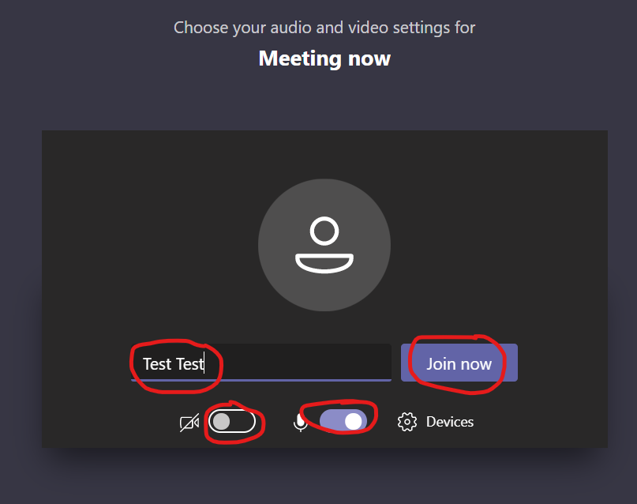

How to Share Screen in a meeting
- To share your screen in a meeting, select Share in your meeting controls

- Then, choose to present your entire desktop (1), an application(2) or a webpage(3)
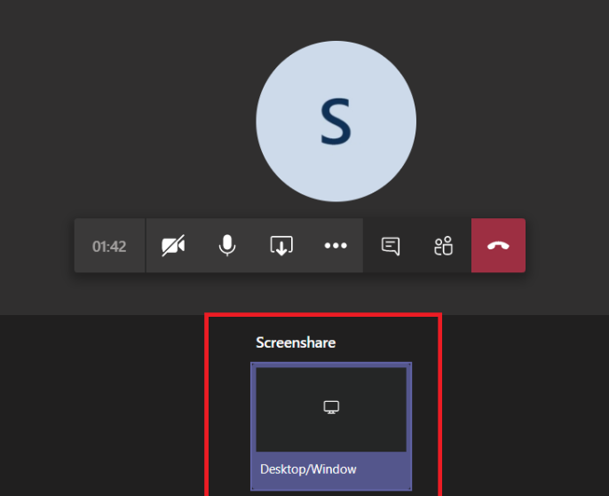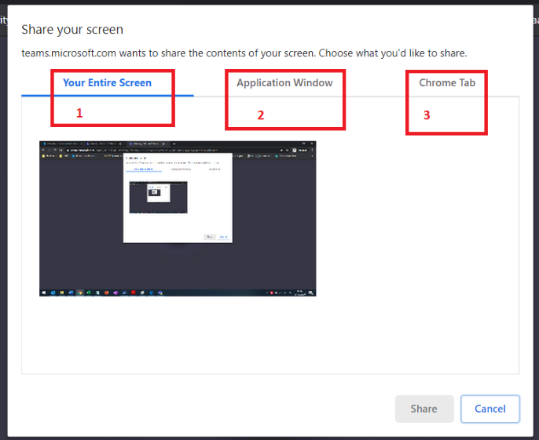
Please be awre that all particpants in the meeting can see what is shared in this manner.

Other useful sources of information.
Useful links below:
Teams on the web at https://teams.microsoft.com.
Microsoft Teams help & learning https://support.office.com/en-us/teams

